Equation Solving Flow Chart

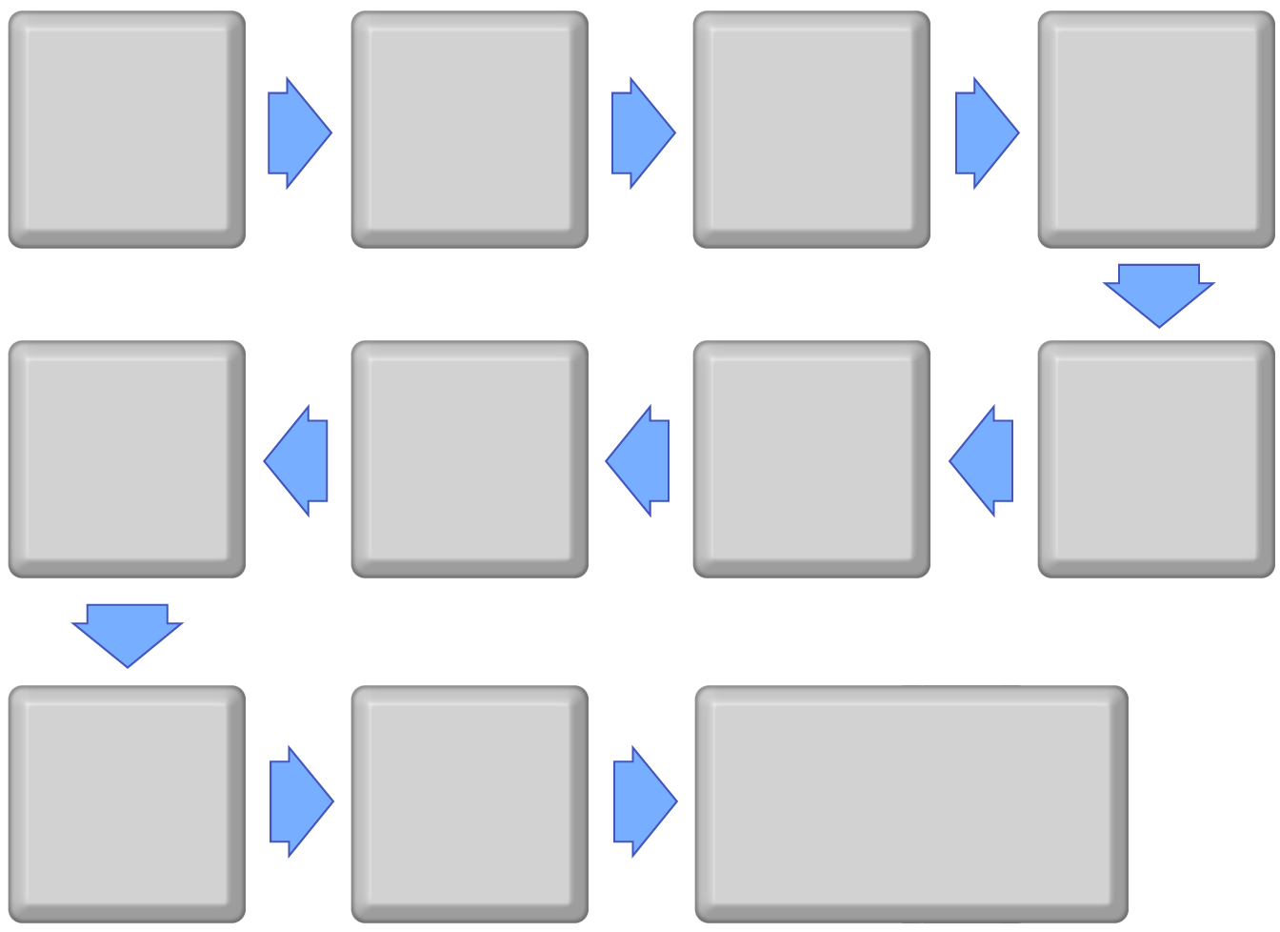
Write Equation:
Do what first?
Rewrite equation:
Then do?
Then do?
Rewrite equation:
Then do?
Rewrite equation:
Rewrite equation:
Then do?
Final Answer:

